CHAPTER 9: Sedimentary, igneous and metamorphic rocks
Worksheet 9.5

The rock cycle
Answers

1. Label the rock cycle diagram using four of the terms from the list.
remelting sedimentary rock weathering and erosion igneous rock metamorphic rock
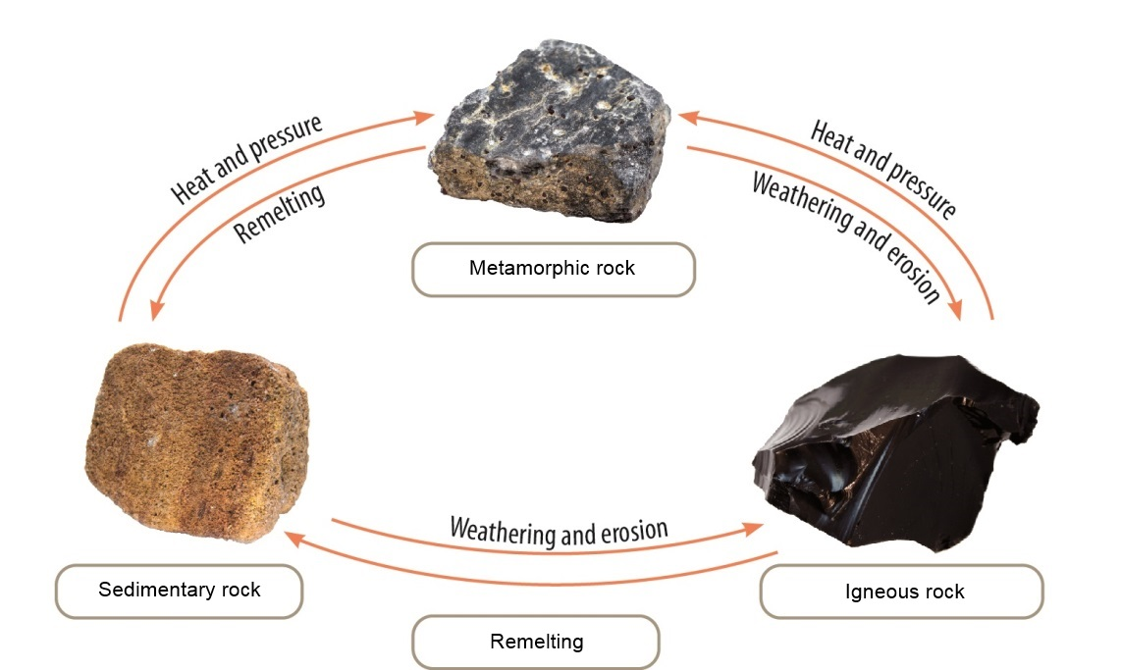
Top photo: Tyler Boyes / Shutterstock.com
Left photo: michal812 / Shutterstock.com
Right photo: Tyler Boyes / Shutterstock.com
2. The three types of rocks illustrated in the rock cycle have particular uses in our society. Complete the table by classifying each rock into its group (sedimentary, igneous, metamorphic) and stating a common use of each rock.
Rock | Classification group | Use in society
Slate | Metamorphic | Roofing, garden walls
Sandstone | Sedimentary | Building, decorative walls
Basalt | Igneous | Blue metal in concrete
3. Metamorphism due to heat or pressure can change a sedimentary rock into a metamorphic rock. Complete the diagram by inserting the names of pairs of rocks from the list.
quartzite limestone marble shale sandstone slate

